** Visvesvaraya Technological University**



**Belagavi, Karnataka.**





**A DBMS MINI-PROJECT REPORT**

**ON**

**“Cricket Tournament Database”**

Submitted to Visvesvaraya Technological University in partial fulfillment of the requirement for the award of Bachelor of Engineering degree in Computer Science and Engineering.

**Submitted by**

**Shashank G Malode 4JN18CS086**

**Shivakumar.L.S 4JN18CS088**

**Ranjan.B 4JN18CS075**

**Under the guidance of**

**Mr. MOHAN H GB.E., M.Tech.. Mr.Hiriyanna G S B.E., M.Tech**

Assistant Professor, Dept. of CS&E Assistant Professor, Dept. of CS&E



Department of Computer Science & Engineering

Jawaharlal Nehru National College of Engineering

Shivamogga - 577 204,January 2020

**National Educational Society ®**





Jawaharlal Nehru National College of Engineering

Department of Computer Science & Engineering

**CERTIFICATE**

This is to certify that the DBMS - MINI project entitled

**“Cricket Tournament Database”**

**Submitted by**

**Shashank G Malode 4JN18CS086**

**Shivakumar.L.S 4JN18CS088**

**Ranjan.B 4JN18CS075**

Students of 5th semester B.E. CSE, in partial fulfillment of the requirement for the award of degree of Bachelor of Engineering in Computer Science and Engineering of Visvesvaraya Technological University, Belagavi during the year 2020-21.

**Signature of Guides**

**Mr.Mohan H GB.E., M. Tech.. Mr.Hiriyanna G S B.E., M.Tech**

Assistant Professor, Dept. of CS&E Assistant Professor, Dept. of CS&E

**Signature of HOD**

**Dr.Poornima K MB.E,M.Tech, Ph.D**

Prof.& Head, Dept. of CS&E

Examiners: 1. 2.

**ABSTRACT**

Cricket Tournament Database Management is a cricket scheduling-based application exclusively for the game of cricket. The Application features schedules, information about teams, records of batting and bowling, creating new schedules, can search about players, it displays rank tables for teams and players. The admin has all authorities to make changes for the database so admin can add players, can add schedules, can add stadiums and also have permission to removing of them from the database. It features with searching of players involved in the game and retrieve the players of the particular match by selecting match number. Also, it can fetch the schedules with their venue and squad available by the team, players selected for the current match. Admin can also authority to update the rating of the teams and also players’ runs

The user’s login window also featured with create an account, player search for players information, getting future match particulars, rankings, cricket boards, stadiums, schedules and their venues. Can fetch the schedules with their venue and squad available by the team, players selected for the current match. The aim is to automate its existing manual system by the help of computerized equipment and full-fledged computer software. Basically the project describes how to manage for good performance and better services for the clients.

**ACKNOWLEDGEMENT**

On presenting the Database Management Systems Mini – Project report on “**Auditorium Management System**”, I feel great to express my humble feelings of thanks to all those who have helped me directly or indirectly in the successful completion of the project work.

I would like to thank our respected guide **Mr.Mohan H G, Assistant Professor, Dept. of CS & E,** and **Mr.Hiriyanna S G, Assistant Professor,Dept. of CS & E,** who has helped me a lot in completing this task, for their continuous encouragement and guidance throughout the project work.

I would like to thank **Dr.Poornima K M,** Professor and Head, Dept. of CSE, JNNCE, Shivamogga and **Dr.Shashidhar K Kudari**, Principal, JNNCE, Shivamogga for all their support and encouragement.

I am grateful to **Department of Computer Science and Engineering** and our institution **Jawaharlal Nehru National College of Engineering** and for imparting me the knowledge with which I can do my best.

Finally, I also would like to thank the whole teaching and non-teaching staff of Computer Science and Engineering Dept.

Thanking you all,

Shashank G Malode 4JN18CS086

Shivakumar.L.S 4JN18CS088

Ranjan.B 4JN18CS075

**CONTENTS**

Abstract 3

Acknowledgement 4

Contents 5

List of Figures 6

**CHAPTER 1: INTRODUCTION 7-9**

* 1. Overview of DBMS 7
  2. History 7
  3. Applications of DBMS 8
  4. Problem statement 9
  5. Objectives of the Project 9
  6. Organisation of Report 9

**CHAPTER 2: REQUIREMENT ANALYSIS 10-15**

2.1 Introduction and classification of SQL 10

2.2 Hardware and Software Requirements 14

2.3 About Technologies used 15

**CHAPTER 3: DESIGN AND IMPLEMENTATION 16-21**

3.1 System design 16

3.2 ER diagram 16

3.3 Schema diagram 17

3.4 Trigger and Stored procedure 19

3.5 Pseudocode 20

**CHAPTER 4: RESULT AND SNAPSHOTS 22-28**

**CONCLUSION AND FUTURE SCOPE 29**

**REFERENCES 30**

**List of figures**

1. ER Diagram 16
2. Relational schema diagram 17
3. Snapshot of index page 22
4. Snapshot of admin and user page 23
5. Snapshot of Admin home page 24
6. Snapshot of Schedule 25
7. Snapshot of player rankings 27
8. Snapshot of add player 28
9. Snapshot of add schedule and add stadium 29

**Chapter 1**

**Introduction**

**1.1 Overview of DBMS**

A Database Management system, or DBMS is a software designed to assist in maintaining and utilizing large collection of data, and the need of such systems, as well as their use ,is growing rapidly. The alternative to using a DBMS is to use ad hoc approaches that do not carry over from one applications to another.

A Database is a collection of related data organised in a way that data can be easily accessed, managed and updated. Any piece of information can be a data. Database is actually a place where related piece of information is stored and various operations can be performed on it.

A DBMS is a software that allows creation, definition and manipulation of database. DBMS is actually a tool used to perform any kind of operation on data in database. It maintains data consistency in case of multiple users.

**1.2. History**

From the earliest days of computers, storing and manipulating data have been a major application focus. The first general-purpose DBMS was designed by Charles Bachman at General Electric in the early 1960s and was called the Integrated Data Store. It formed the basis for the network data model, which was standardized by the Conference on Data Systems Languages (CODASYL) and strongly influenced database systems through the 1960s. Bachman was the first recipient of ACM's Turing Award (the computer science equivalent of a Nobel Prize) for work in the database area; he received the award in 1973.

In the late 1960s, IBM developed the Information Management System (IMS) DBMS, used even today in many major installations. IMS formed the basis for an alternative data representation framework called the hierarchical data model. The SABRE system for making airline reservations was jointly developed by American Airlines and IBM around the same time, and it allowed several people to access the same data through. An interesting phenomenon is the emergence of several enterprise resource planning (ERP) and management resource planning (MRP) packages, which add a substantial layer of application-oriented features on top of a DBMS. Widely used packages include systems from Baan, Oracle, PeopleSoft, SAP, and Siebel.

**1.3. Applications of DBMS**

Nowadays DBMS are used in almost all the areas ranges from science, engineering, medicine, business, industry, government, art, entertainment, education and training.

**DBMS in Banking**

We make thousands of transactions through banks daily and we can do this without going to the bank. That is all possible just because of DBMS that manages all the bank transactions.

**DBMS in Universities and colleges**

Examinations are done online today and universities and colleges maintain all these records through DBMS. Student’s registrations details, results, courses and grades all the information are stored in database.

**DBMS in Online Shopping**

Online shopping has become a big trend of these days. No one wants to go to shops and waste his time. Everyone wants to shop from home. So all these products are added and sold only with the help of DBMS. Purchase information, invoice bills and payment, all of these are done with the help of DBMS.

**DBMS in Military**

Military keeps records of millions of soldiers and it has millions of files that should be keep secured and safe. As DBMS provides a big security assurance to the military information so it is widely used in militaries. One can easily search for all the information about anyone within seconds with the help of DBMS.

**DBMS in Telecommunications**

Any telecommunication company cannot even think about their business without DBMS. DBMS is must for these companies to store the call details and monthly post-paid bills.

**1.4 Problem Statement:**

The problem of maintaining unique details of teams, players, venues of the teams manually is difficult as it is high in numbers and it is difficult to maintain statistics of each players participating in a cricket tournament

**1.5 Objectives:**

* Database for Cricket tournament is used to get all the information of the activities that is going on in the tournament.
* It can be used to retrieve any details of any team, players, or other members participating in the tournament.
* We can directly retrieve complete details of any player or team related to the tournament with ease.
* It reduces the workload of storing each and every data manually.

**1.6 Organization of the Report:**

This section deals with the Introduction and organization of the project report. Chapter 2 discusses the Specific to the problem-Requirement Analysis-Design. Chapter 3 discusses the Design and Implementation. Chapter 4 include results and snapshot and. Chapter 5 gives the conclusion and future enhancement of the project.

**Chapter 2**

**REQUIREMENT ANALYSIS**

SQL stands for structured query language. Use for storing, manipulating and retrieving relational database data. SQL queries to retrieve data from database same as you can add and manipulate database data.

SQL is a very powerful database language used to store data into databases. SQL is loosely typed language so you can learn easily.

SQL is a great tool with web languages such as PHP, Python, Java, ASP etc to build dynamic applications.

**2.1 Classification Of SQL**

TYPES OF SQL STATEMENTS (DML, DCL, TCS, SCS, DDL commands):

SQL statements are divided into five different categories:

Data definition language, Data manipulation language, Data control language, Transaction control statements, Session control statements.

Data definition statements are used to define the database structure or table.

**STATEMENT DESCRIPTION**

CREATE Create new database / table.

ALTER Modifies the structure of database / table.

DROP Delete a database/table.

TRUNCATE Remove all table records.

RENAME Rename the database/table.

**2.1.1Data Manipulation Language (DML) Statements:**

Data manipulation statements are used for managing data within table object.

|  |  |
| --- | --- |
| **STATEMENT** | **DESCRIPTION** |
| SELECT | Retrieve data from the table. |
| INSERT | Insert data into table. |
| UPDATE | Updates existing data with newdata within a table. |
| DELETE | Deletes the records rows fromthetable. |
| MERGE | Merge statements to insert new records or updates existing records depending on condition matches or not  . |
| LOCK TABLE | Lock Table statements to lock one or more table in a specified mode. Table access denied to other users for the duration of your table operation. |
| CALL EXPLAIN PLANT | Statements are supported in PL/SQL only for executed dynamically. CALL a PL/SQL program or EXPLAIN PATH access the data path. |

**2.1.2 Data Control Language (DCL) statements:**

Data control statements are used to give privileges to access limited data.

**STATEMENT DESCRIPTION**

GRANT Gives privileges to user for accessing database data.

REVOKE Take back for given privileges.

ANALYZE ANALYZEs the statement to collect statistics information about index, cluster, table.

AUDIT It traces the occurrence of a specific SQL statements or all SQL statements during the user session

COMMENT Write comment to data table.

**2.1.3 Transaction Control Statements (TCS):**

Transaction control statements are used to apply changes permanently saved into database.

**STATEMENT DESCRIPTION**

COMMIT Permanent work save into database.

ROLLBACK Restores the database to original form since the last COMMIT.

SAVEPOINT Create SAVEPOINT for later use ROLLBACK the new changes.

SET TRANSACTION SET TRANSACTION command set the transaction properties such as read-write/read only access

**2.2 Hardware and Software Requirements:**

**2.1.1 Hardware Requirement**

The section of hardware configuration is an important task related to the software development insufficient random-access memory may affect adversely on the speed and efficiency of the entire system. The process should be powerful to handle the entire operations. The hard disk should have sufficient capacity to store the file and application

Processor : Intel PentiumT4200/ Intel Core Duo 2.0 GHz / more

RAM : Minimum 1GB RAM capacity

Hard disk : Minimum 40 GB ROM capacity

Cache Memory : L2-1 MB

GPU : Intel HD Graphics

**2.1.2 Software Requirement**

A major element in building a system is the section of compatible software since the software in the market is experiencing in geometric progression. Selected software should be acceptable by the firm and one user as well as it should be feasible for the system.

This document gives a detailed description of the software requirement specification. The study of requirement specification is focused specially on the functioning of the system. It allows the developer or analyst to understand the system, function to be carried out the performance level to be obtained and corresponding interfaces to be established.

Front End : PHP(Hypertext preprocessor)

Back End : XAMPP server, My SQL

Operation System : Windows 7 Or Windows 8.1 Or Windows 10

Client side : CSS (cascading Style sheet)

**2.2 About Technologies used**

* **HTML** is integrated in **PHP**. It provides a means to structure text-based information in a document. It allows users to produce web pages that include text, graphics and hyperlinks.
* **CSS (**Cascading Style Sheets) is a style sheet language used for describing the presentation of a document written in a mark-up language. Although most often used to set the visual style of web pages and user interfaces written in HTML and XHTML, the language can be applied to any XML document.
* **MYSQL** is the language used to manipulate relational databases. It is tied closely with the relational model. It is issued for the purpose of data definition and data manipulation. Program runs as a server providing multi-user access to a number of databases. MySQL is a multithreaded, multi-user SQL database management system (DBMS). It includes facilities to add, modify or delete data from the database, ask questions (or queries) about the data stored in the database and produce reports summarizing selected contents.
* **PHP** is a scripting language originally designed for producing dynamic web pages. It has evolved to include a command line interface capability and can be used in standalone graphical applications.PHP is a general-purpose scripting language that is especially suited for web development. PHP generally runs on a web server, taking PHP code as its input and creating web pages as output. It can also be used for command-line scripting and client-side GUI applications. PHP can be deployed on most web servers, many operating systems and platforms, and can be used with many relational database management systems. It is available free of charge, and the PHP Group provides the complete source code for users to build, customize and extend for their own use.PHP stores whole numbers in a platform-dependent range. This range is typically that of 32-bit signed integers. PHP has hundreds of base functions and thousands more from extensions. These functions are well documented on the PHP site. It requires MySQL connection between the front end and back end components to write to the database and fetch required data.

**Chapter 3**

**DESIGN AND IMPLEMENTATION**

**3.1. System Design**

The system design process involves developing several modules of the system at different levels of abstractions. Here we put ER diagram and schema diagram of Cricket Tournament Database management system.

**3.2. E-R Diagram**

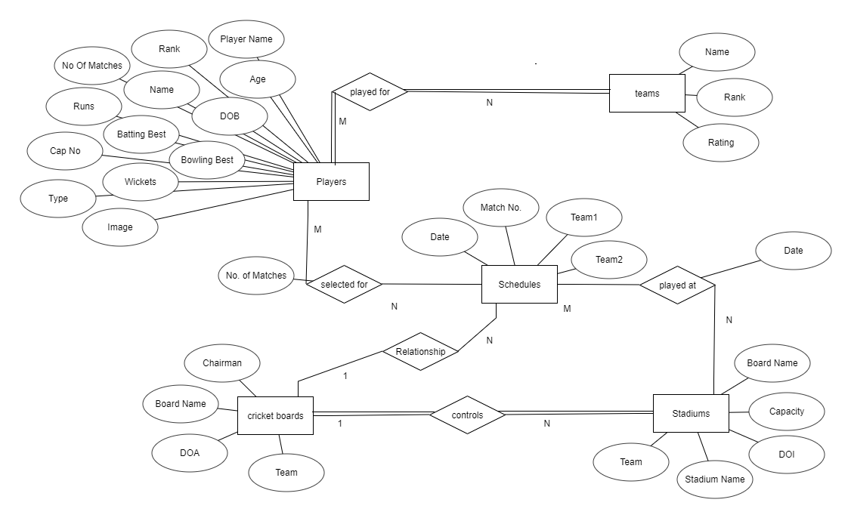

Fig. 3.1 ER Diagram of Auditorium Management System

**3.3. SCHEMA DIAGRAM**

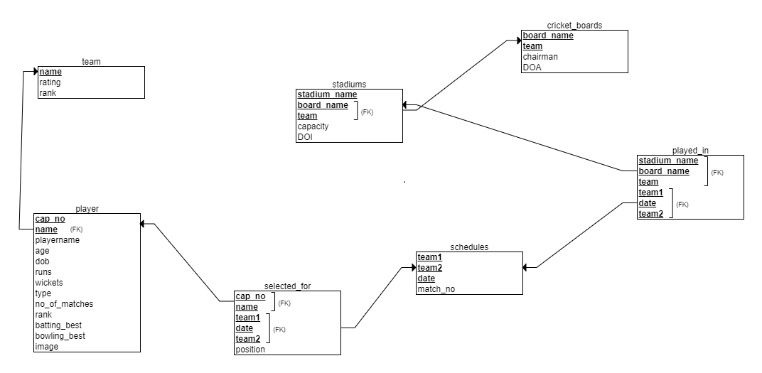

Fig 3.2 Relational schema diagram of Cricket Tournament Database Management System

* Cricket Tournament management database consists of the following relations:

1. Player
2. Teams
3. Cricket Boards
4. Stadiums
5. Schedules

The above five relations consists of respective attributes:

1. Player: Information about each player is stored here. The required attributes are

* + - cap_no
    - name
    - age
    - dob
    - runs
    - wickets
    - type
    - no_of_matches
    - ranking
    - bating_best
    - bowling_best
    - image

2.Team: Information about player playing in each team is stored here. The attributes

present are

* name
* rating
* rank

3.Cricket_boards: Each team has a board. The attributes are

* board_name
* team
* chairman
* DOA

4.Stadiums: the place where matches are to be played.The attributes present are

* stadium_name
* board_name
* team
* capacity
* DOI: date of innaguration

5. Schedules: decides when the matches are about to be played. The attributes are

* team1
* team2
* date
* match_no

**3.4TRIGGER AND STORED PROCEDURE**

**3.4.1** **Stored Procedure:**

CREATE DEFINER=`root`@`localhost`

PROCEDURE `stadium`() NO SQL

select * from stadiums

**3.4.2 Trigger:**

CREATE TRIGGER `default_date`

BEFORE INSERT ON `stadiums`

FOR EACH ROW

set new.DOI=CURRENT_DATE();

CREATE TRIGGER `update` BEFORE UPDATE ON `player`

FOR EACH ROW BEGIN

IF (new.runs<old.runs) THEN SET new.runs=old.runs;

IF (new.wickets<old.wickets) THEN SET new.wickets=old.wickets;

END IF;

IF (new.no_of_matches<old.no_of_matches) THEN SET new.no_of_matches=old.no_of_matches;

END IF;

END IF;

END

* 1. **Psuedocode:**

**To create a connection to a database:**

<?php

$con=mysqli_connect("localhost","root","","cricket");

?>

**To** close **connection to database:**

**<**?php

mysqli_close($con)

?>

**View/Select:**

$player=$_POST['playername'];

$query="select * from player where playername like '%$player%'";

$res=mysqli_query($con,$query);

if(mysqli_num_rows($res)>0){

while($row = mysqli_fetch_assoc($res))

**Insert/Add:**

To insert or add in any table,

$query="insert into 'table_name'() values()";

if(mysqli_query($con,$query))

**Delete:**

To delete a ‘player’ entity

$sql="delete from player where playername like '$player'";

if(mysqli_query($con,$sql)==true){

$sql1 = "SELECT * from player where playername like'$player'";

To delete a ‘schedule’ entity,

$match_no=$_POST['match_no'];

$sql="delete from schedules where match_no='$match_no'"

**Update:**

$q="update player set runs='$runs',wickets='$wickets',no_of_matches='$no_of_matches' where playername='$name'"

$query="select * from player where type='batsman' order by runs desc";

$result=mysqli_query($con,$query);[$i]=floor(1)

$query="select * from schedules s,played_in p where s.date=p.date and s.team1=p.team1 order by s.date";

$result=mysqli_query($con,$query);

$q="update team set rating='$rating' where name='$name'";

**Chapter 4**

**RESULTS AND SNAPSHOTS**

**INDEX:** 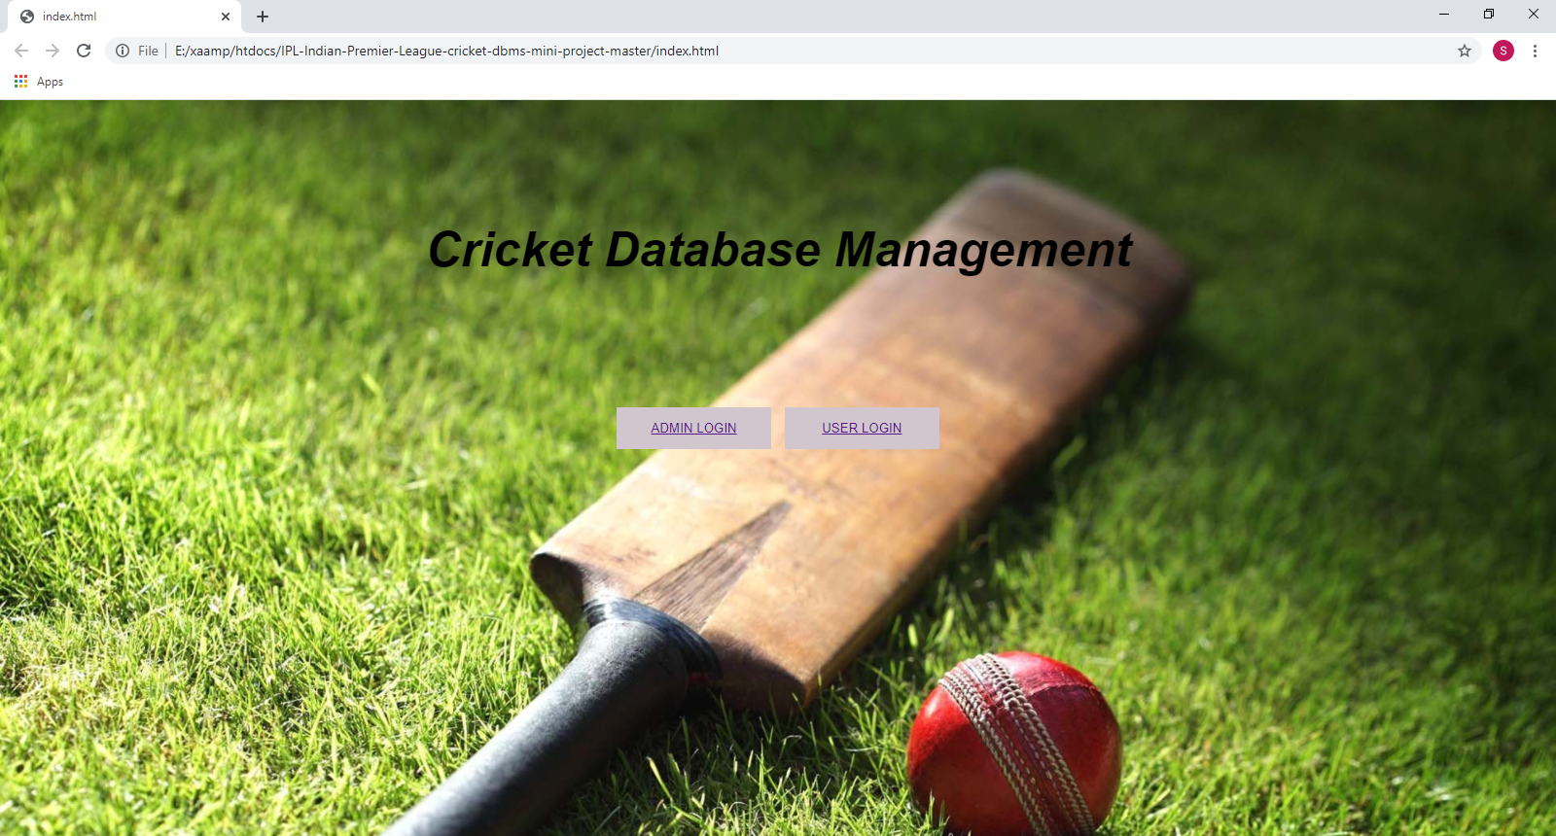

Fig 4.1 Snapshot of index page

**Admin login:** 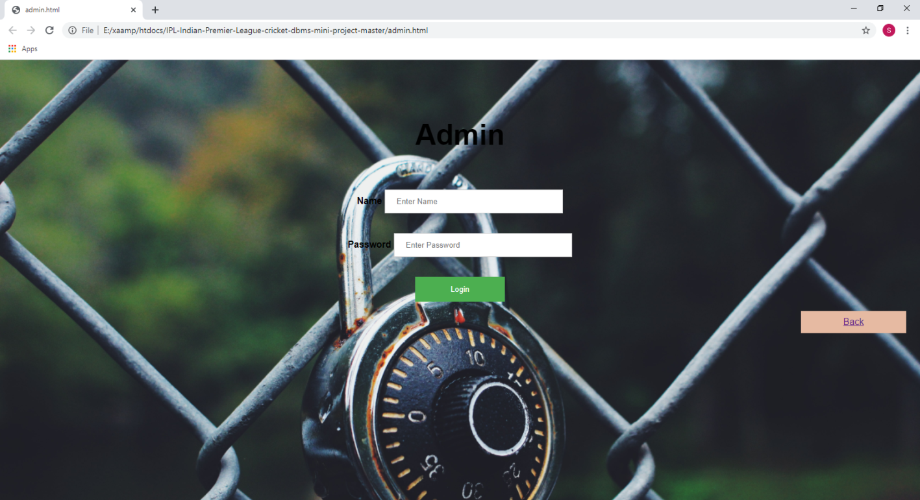

Fig 4.2 Snapshot of admin login page

**User login:**

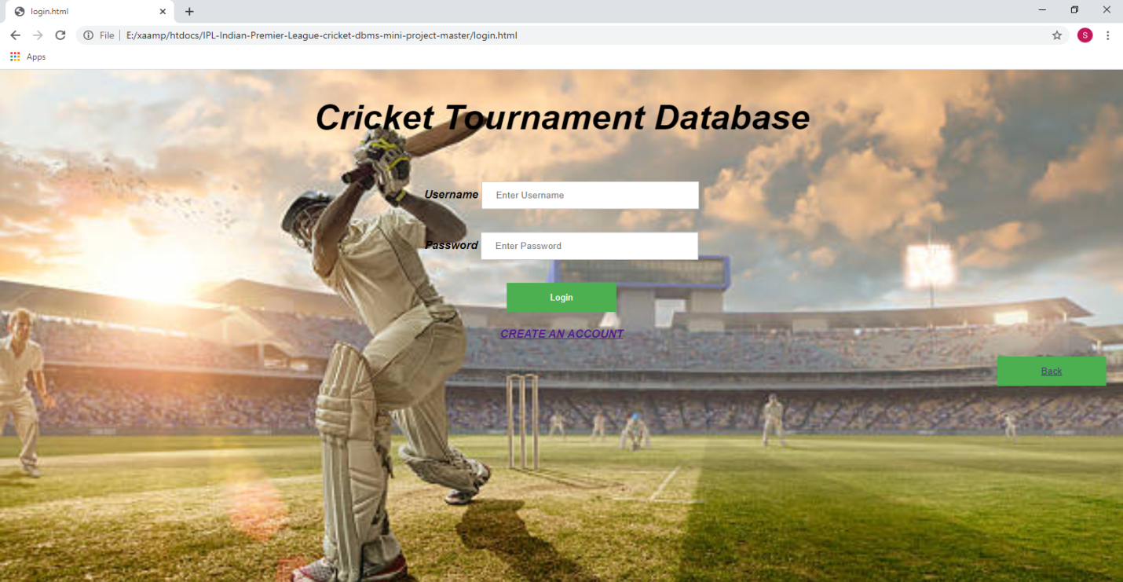

Fig 4.3 Snapshot if user login page

**Admin Home Page:** 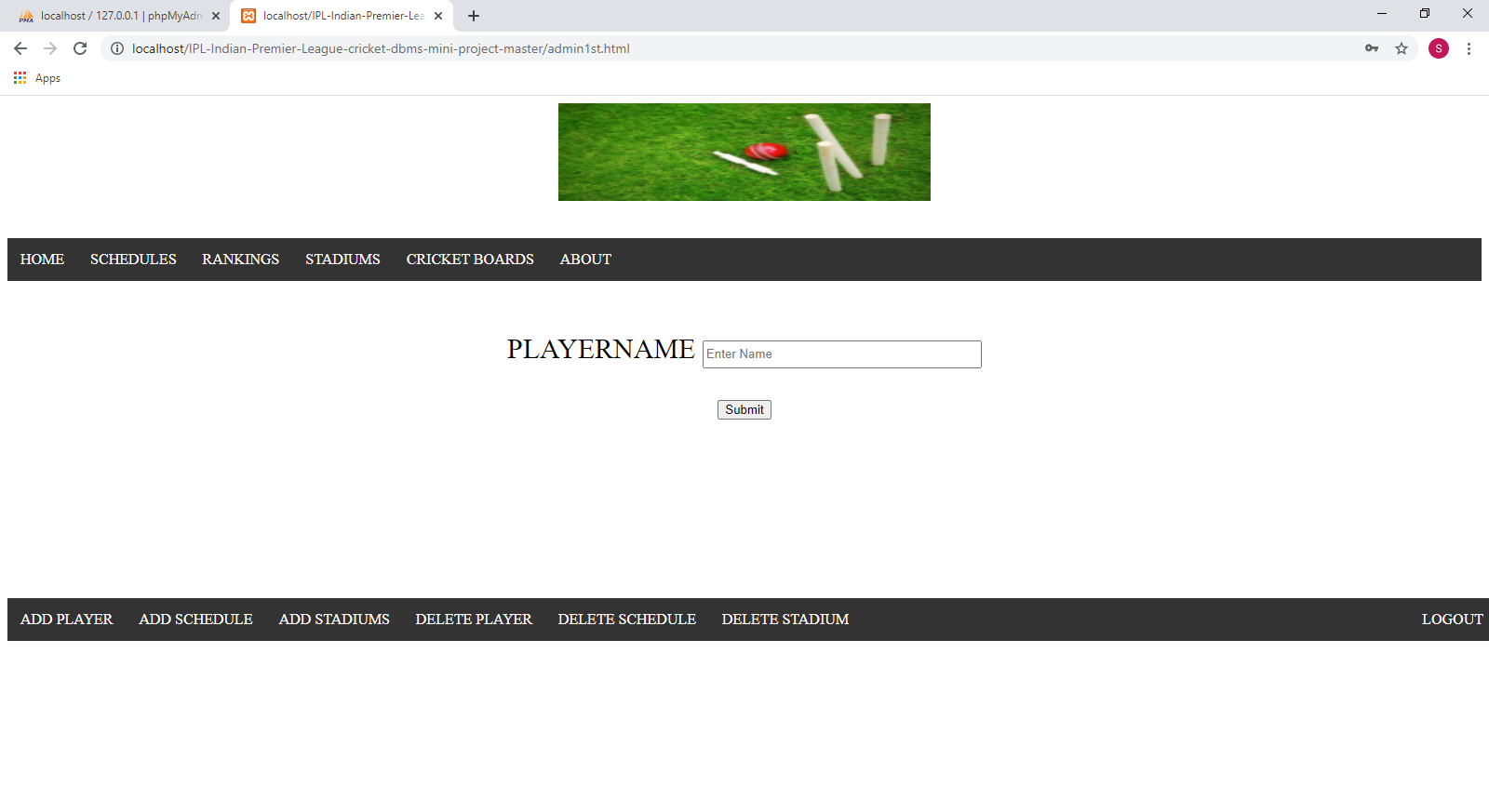

Fig 4.4 Snapshot of admin home page

**User Account Create page:** 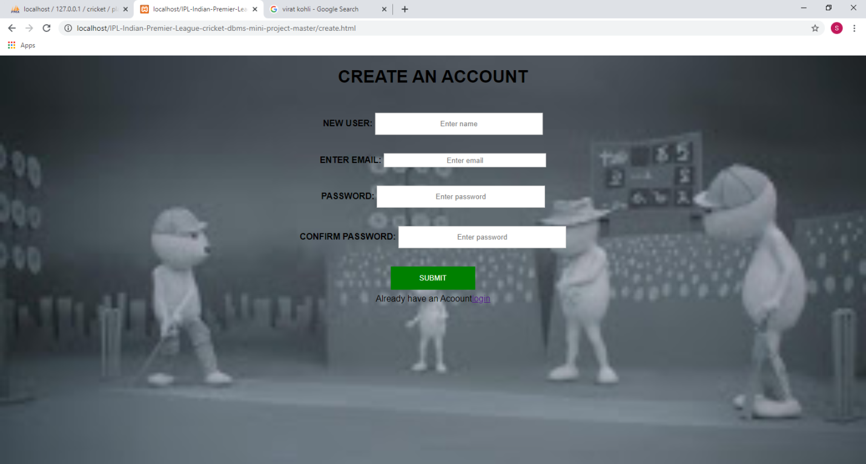

Fig4.5 Snapshot of user account create page

**User Home page:** 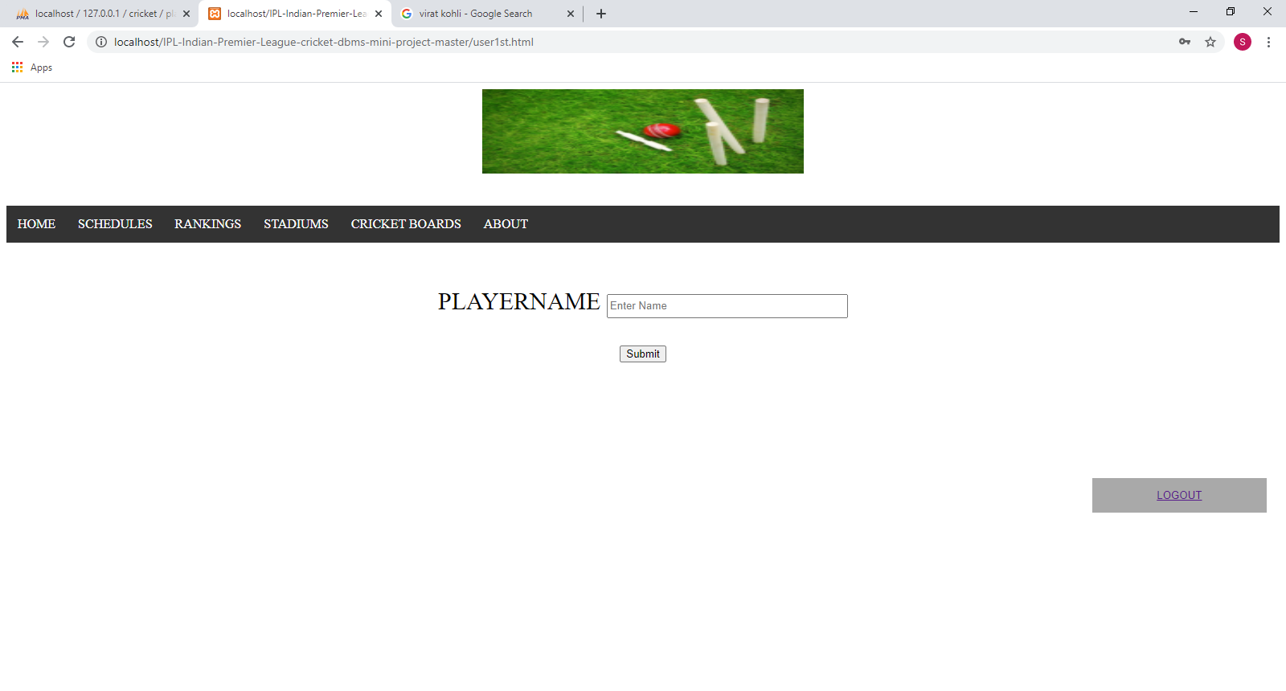

Fig4.6 Snapshot of User homepage

**Schedules:** 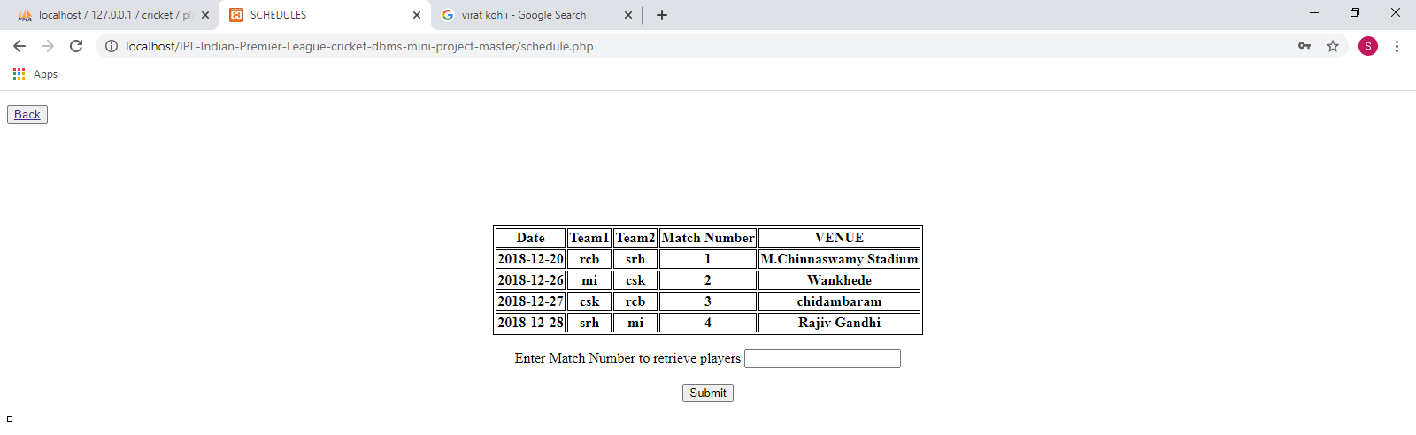

Fig 4.7 Snapshot of Schedules

Schedule details: 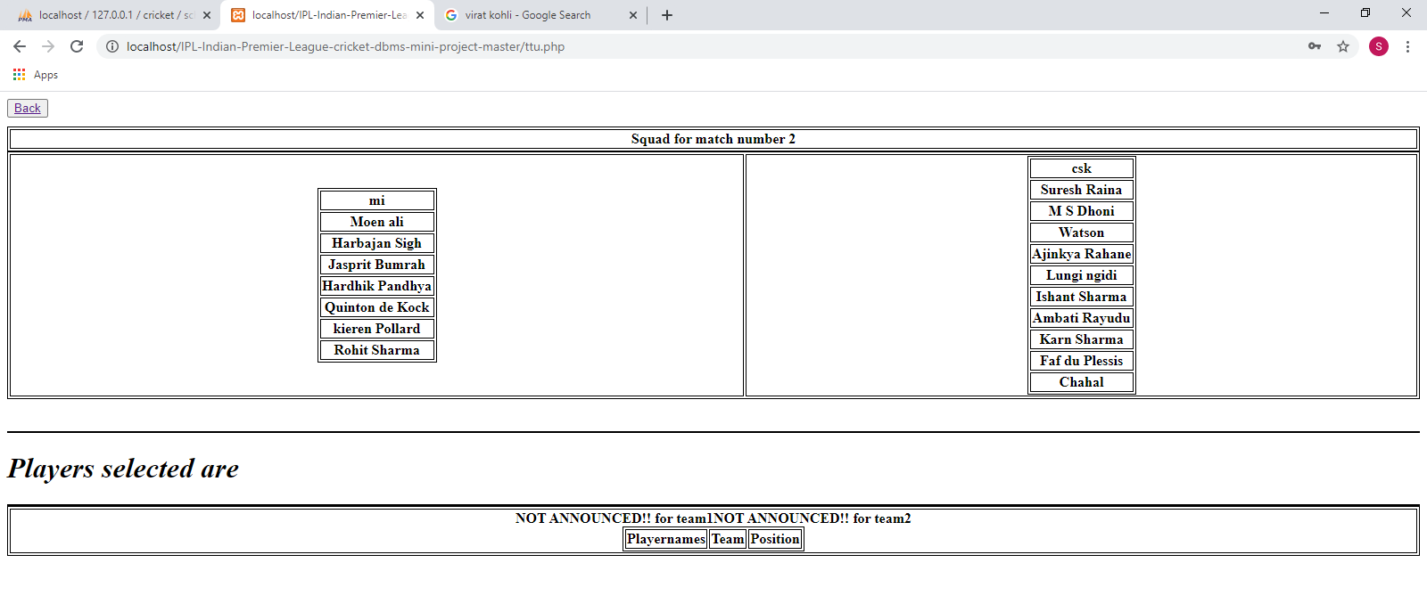

**Rankings:** 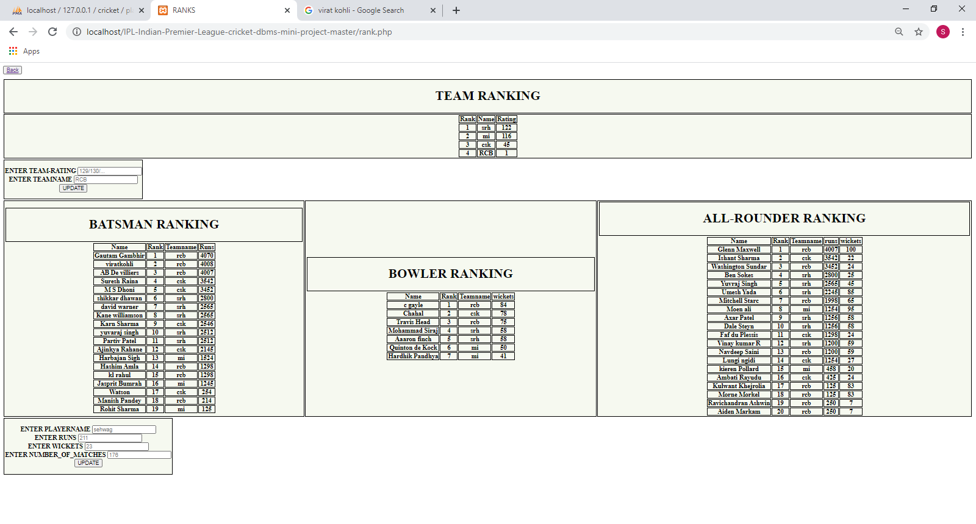

Fig 4.8 Snapshot of player rankings

**Player Search:** 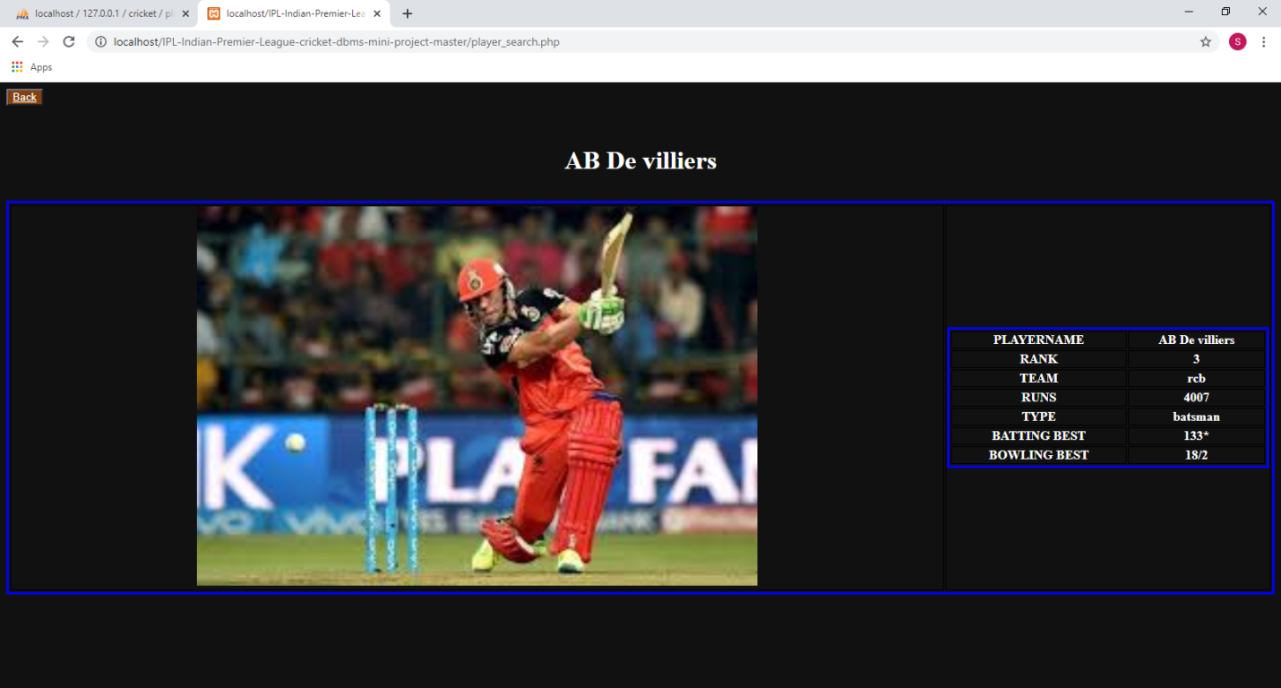

Fig 4.9 Snapshot of player search

**Add player:** 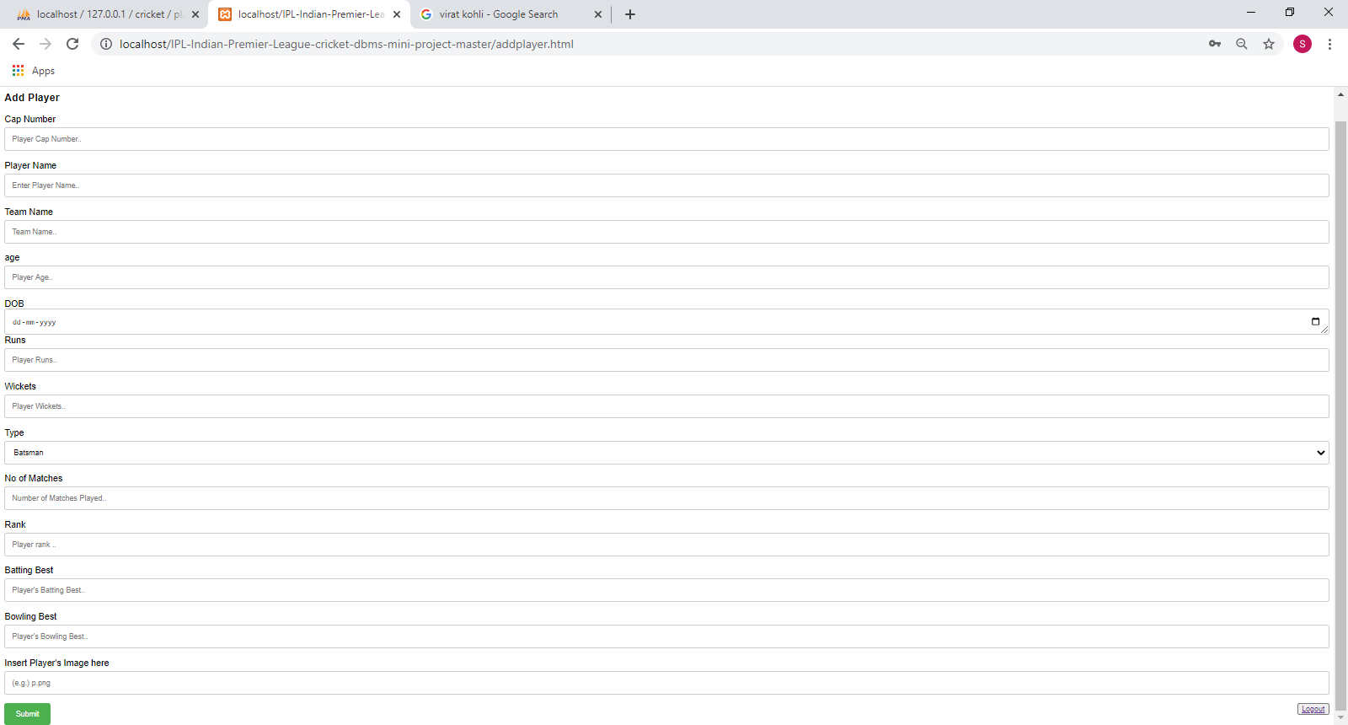

Fig 4.10 Snapshot of Add player

**Add Schedule:** 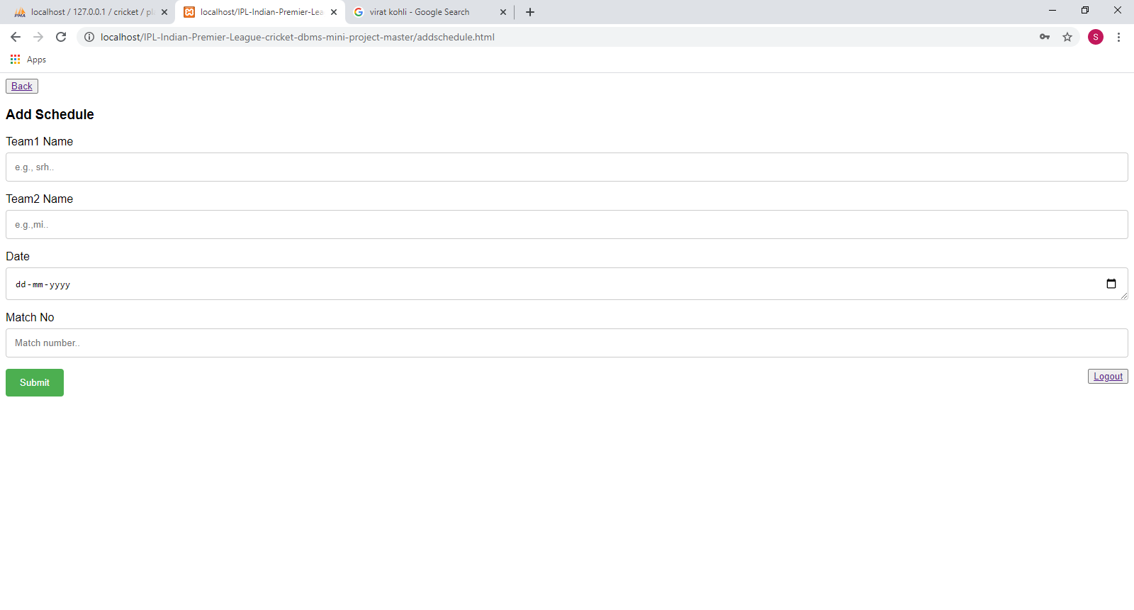

Fig 4.11 Snapshot of add schedule

**Add Stadium:** 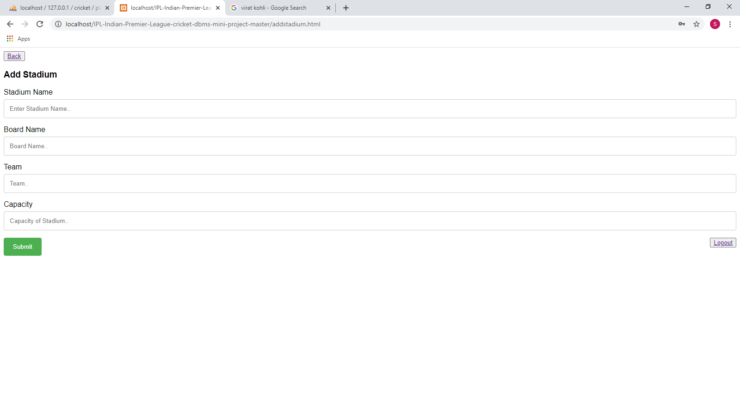

Fig 4.12 Snapshot of add stadium

**Conclusion**

The project, developed using PHP and MySQL is based on the requirement specification of the user and the analysis of the existing system, with flexibility for future enhancement. The expanded functionality of today’s software requires an appropriate approach towards software development. This Cricket Tournament database management software is designed for people who want to manage various particulars can be known by recording them in the database. various records and particulars about match got increased rapidly. Thereby the numbers of matches and there is going to be increased day-by-day. And hence there is a lot of strain on the person who are watching the IPL to know about future matches and also to see the records done by various players and getting details in fingertips. Identification of the drawbacks of the existing system leads to the designing of computerized system that will be compatible to the existing system with the system which is more user friendly and more GUI oriented.

**Future Scope of the project**

The current project is just based on taking the information and storing in respective data tables and representing the information in the different required forms and has the ability to search using the attribute. There are some enhancements which can be implemented further. They are as follows:

* Module that automatically gives the information about various cricket boards, stadiums and also rankings of various IPL teams and players by selecting or entering the relevant required item.
* Module that gives information about completely filled and partially filled information on various particulars.
* Can create module such that the user can login and gain information through the window.
* Make this project to the scope for players also.

**REFERENCES**

1. RamezElmasri and ShamkantBNavathe, “Database systems Models,Languages,Design and Application Programming”, Pearson, 7th Edition, 2017.
2. Raghu Ramakrishnan, and Gehrke, “Database management systems”, McGraw Hill, 3rd Edition, 2014.
3. [http://stackoverflow.com](http://stackoverflow.com/)
4. <https://www.w3schools.com>
5. <http://www.phptpoint.com>
6. <https://www.bootply.com/>
7. <https://www.tutorialspoint.com>